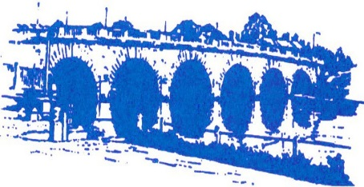
LIONS CLUB
OF
MAIDENHEAD
International Association of Lions Clubs | Chartered 1973 | District 105D England

1973 – 2013 and still going strong!
For 40 years, we have been ‘Ordinary people doing amazing things’.
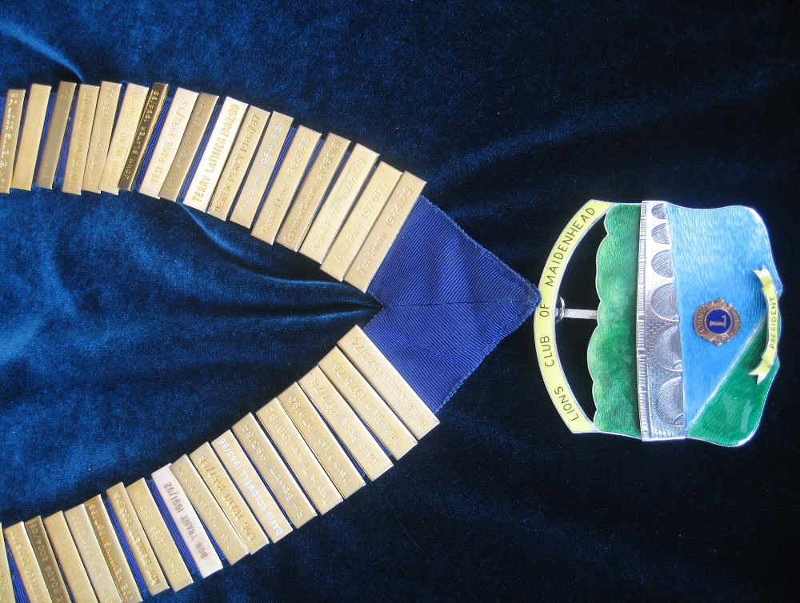

In January 1973 some like-minded locals joined together with a view to forming a new Lions Club in Maidenhead. Over the next few months and with the advice and assistance of Windsor Lions Club, the necessary steps were taken. On 25th May the formal Charter was issued and the new Maidenhead Club with 24 Members became part of Lions Clubs International, the largest volunteer community service organisation in the world. A celebratory Dinner and Dance was held on 7th September at the old Skindles Hotel.
After the formation of the club, regular twice-monthly Business Meetings were held at the Shire Horse Inn and it was our aim to publicise our new Club as widely as possible in the area. We acted as ‘home help’ to the needy, undertaking various gardening, painting and decorating jobs and in one instance insulating an old person’s loft (this was the worst job I can remember doing in 40 years!).
With very little money in the Bank, we had to raise funds quickly to cover any pending welfare commitments. Our first fund-raising event was ‘A Cavalcade of Fashion’ at Skindles with Raymond ‘Mr Teasy-Weasy’ demonstrating his latest hair creations. 350 tickets were sold with the profits going to the NSPCC.
Further income was raised by our participation in local Fairs and fetes, including Littlewick Green Show, Holyport Fair, the former Knowl Hill Steam Fair and Wokingham Donkey Derby, the latter of which we still support today with our Train, though it is now called the Wokingham May Fayre.
Here is a photo of our Lion Safari stall at the Knowl Hill Steam Rally in the 1980’s. 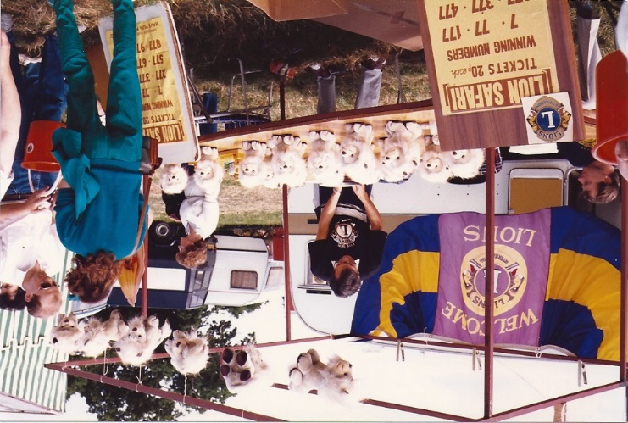

The new Magnet Leisure Centre was opened in the mid-1970’s and we planned to organise a Concert there with an audience of around 1400 people. Abba had won the Eurovision Contest in 1974, so we wrote to them asking if they would contemplate appearing locally. 40 years later and now knowing the worldwide success of Abba, it is hard to believe that we even considered writing to them. However we did obtain a reply and a promise that they would contact us when their schedule for the following year was finalised. Needless to say, we did not receive any further communication! However we went ahead and organised a Syd Lawrence Charity Concert in the Leisure Centre at the beginning of 1976 and followed this up the following year with a similar concert.
In March 1976 the Leisure Centre hosted possibly the biggest function they have staged to date, a formal sit down Dinner for 800 people including Prince Philip, Duke of Edinburgh; the Centre had been transformed into a festive Big Top during the day with Chandeliers etc; our Club ran a Grand Tombola on an evening which we shall always remember.
To help our finances from the very beginning we helped Windsor Club with their annual sponsored Horse Ride, firstly by manning some of the ‘jumps’ and later with the slightly easier option of organising the car parking. In return Windsor Lions gave us a donation for the number of our Members present. We continue to support this event today.
Starting in the late 1970’s, we made-up and distributed a large number of food parcels for old, needy people each Christmas, a project which has increased substantially and remains one of our major annual welfare projects, with over 350 deliveries. The only difference is that now we collect food from outside local Supermarkets over 2 weekends in December, whereas in the early years the food was collected house-to-house.
This photo shows parcel make up in the 1980’s at the Ray Social Club.
We have also used the Police station Gym, and currently Clare’s Court School Gym.
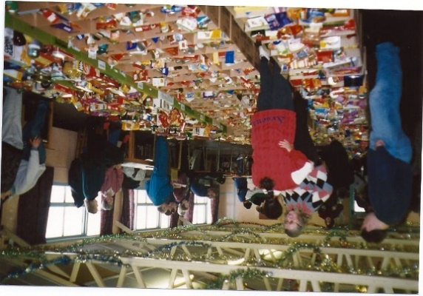
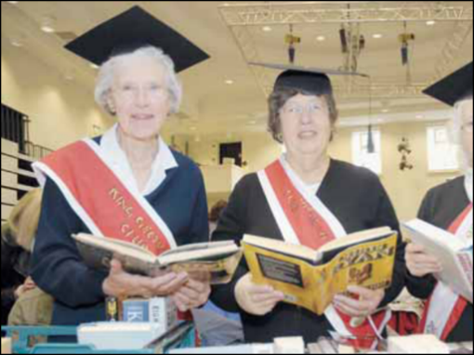
In the autumn of 1978, the local Branch of Home Farm Trust organised the 1st Combined Charities Fair in the Desborough Suite of the Town Hall. It was intended that a different Charity would take on the administration each year. However because very few of the Charities had the manpower to organise such an event, this did not happen. Therefore, after the third Fair, which was run jointly by Maidenhead Lions and Cruse, we took over the organisation and continue to run this very successful event. For several years, our wives organised a Coffee Bring & Buy Stall in the Desborough Suite, having been given the facility of the Hall free by the Mayor at the time. This picture shows one of the charities, competing on the ‘Best dressed stall competition’.
Early in 1982 we organised an Antiques Valuation Day in the Desborough Suite of the Town Hall arranged through Sotheby’s in London. It was a great success. Our contact and chief valuer on the day was David Battie of BBC ‘Antiques Roadshow’ fame.
In June 1982 we assisted at various events in celebration of Maidenhead 400 and we also staged an Old Tyme Music Hall in the Desborough Suite. This was a sell out with our Ladies in costumes supplied by Henry Greene - the picture tells the story!
During the year we were contacted by several members of the Lions Club of Kortrijk who were on a visit to the U.K. The town of Kortrijk in Belgium is twinned with Maidenhead. Following a short visit to Maidenhead they welcomed many of us back into their homes in Belgium the following year, where we were royally entertained. Three years later we returned the invitation and hosted many of their members in our homes. But no agreement was made as to the possibility of our clubs twinning. Nevertheless, regular contact was made between several members of both Clubs for many years afterwards.
In July 1981 a congratulatory telegram was sent to the Prince and Princess of Wales upon the occasion of their Wedding and we received a thank you telegram in return. With emails these days, telegrams are now of course a thing of the past. It turned out that the couple needed more than our good wishes!!
During the 1980’s we attended various Celebrity Nights at Blazers Night Club in Windsor. As a reward for selling a few tickets we were permitted to run a Grand Raffle on these evenings and on one occasion a Charity Auction. These events were very profitable to us bearing in mind that around 1000 people attended such Shows.
In March 1984 Maidenhead Club hosted the Lions District 105D Convention which was a very large commitment to undertake bearing in mind that we were still a relatively young Club. We had been to similar Conventions in the Channel Islands and Reading, so we knew the amount of work involved in such a venture. The venue was the Crest Hotel in Maidenhead and the weekend turned out to be a real success; we were able to stage a memorable 1920’s Night on the Friday and a formal Dinner on the Saturday evening with the late Patrick Moore as the Guest Speaker. This photo shows us promoting the convention.
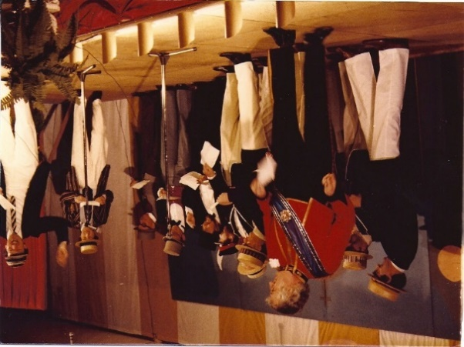

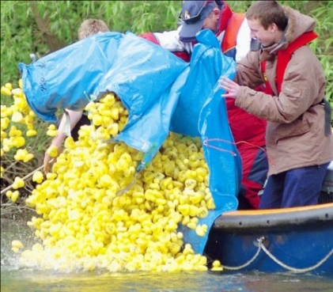
We had been fortunate in being granted the facility of Boulters Island for an annual event. For several years we organised a Summer Strawberry Fayre but this gave way after a few years for a more successful Duck Derby and Family Fun Day, which we still run today, and continues to be one of our major fund raisers each year. The Maidenhead Sea Cadets help with launching & retrieving the ducks for us.
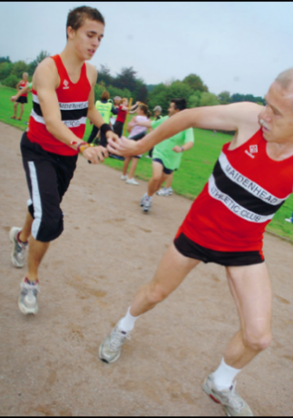
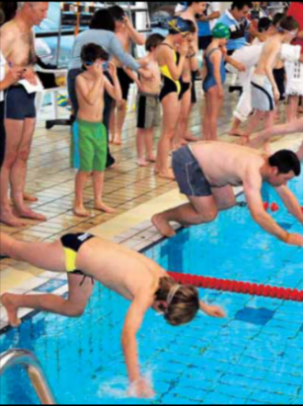
In January 1986, we ran our first Sponsored Swimarathon after seeing the success of a similar Lions event in Jersey. We hoped at the time to raise sufficient funds to cover the purchase of a Defibrillator for a local Ambulance but in the event, we made in the region of £15,000 and we were able to purchase 3 such items. With a lot of hard work by the Activities Committee this is now our largest event of the year both in the number taking part and in the amount of Sponsorship raised.
A newer but now established annual event is the FundRun each September, run on similar lines to the Swimarathon. This has the potential to grow into another major function for the Club.
Following many years hosting a successful Summer Jazz Evening, firstly in a marquee on Glen Island and more recently in Magnet Leisure Centre, a ‘change of music’ was decided upon in 2013, and in June an Elvis Presley Tribute Act was very highly praised; maybe this will be the start of another regular music event each Summer. This photo shows the Pete Allen Jazz Band a few years ago in the Marquee at Glenn Island.
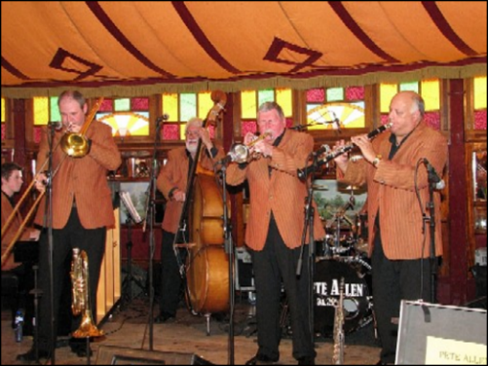
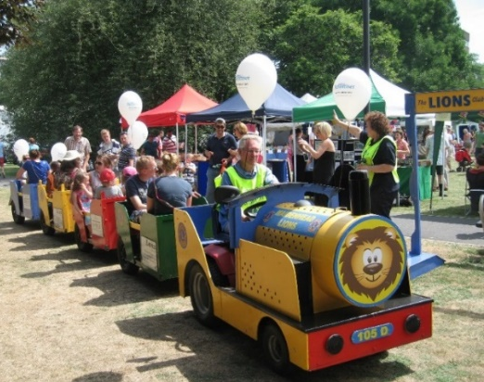
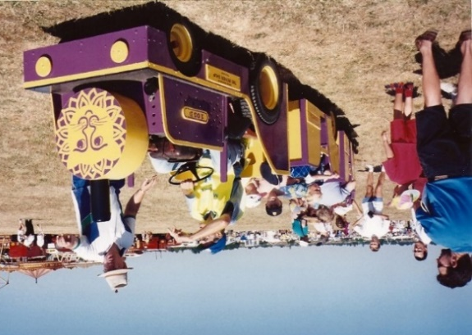
With all the various events mentioned above, one cannot ignore the vital provider of funds and fun afforded by the Lions Fun Train. This goes to numerous events over the summer months and continues to be enjoyed by all its passengers, young and old alike. In recent years, our train has transported Father Christmas around Wokingham for their Christmas Carnival.
These photos of the same train illustrate the contrast between then & now. The first shows it in the 1990’s and the second was taken in 2013 at the Maidenhead Festival in Kidwells Park.
This train is a ‘world apart’ from the purple and gold coloured caravan which the Club owned in 1975 for a short period with the intention of selling snacks at local fetes. This did not really get off the ground and although used for publicity for a short period its ‘days were numbered’ and it was disposed of fairly quickly!
In May 1998 as part of our Silver Jubilee celebrations, we donated two seats to the local community, which were placed on Ray Mill Island. In addition to the work already mentioned, we continued to purchase and install Care-Line telephones for those living on their own who have on-going health problems and we also provided monies for a Water Well via a Lions Club in Nigeria. We undertook evening car rides for the elderly and other ad-hoc taxi services for the old and infirm as and when needed. It would take far too many pages to list all the good work that has been undertaken by the Club and its Members over the years and currently we are donating in the region of £50000 each year to worthwhile local causes.
The success of a Club lies in its Members and we have been fortunate in operating a happy Club over 40 years and that is why we continue so successfully today. We involve not just our Members but their wives, husbands, families, friends etc. We also organise various social activities and often join other local Lions clubs for their social events too. Every year we hold a Charter Anniversary Lunch. This started out as a formal Dinner Dance, then a Dinner and now a formal Lunch which is preferred by most Members (and their pockets!).
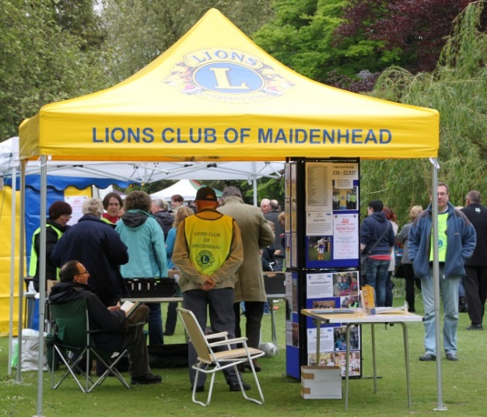
Mention was made above that at the time of our Charter we had 24 members. Over the years we have been able to maintain a good level of membership and remain today one of the largest Clubs in the South of England. At the time of writing our membership is 40 and there have been very few times over the years when it has been lower than 28. Unfortunately the average age of our Members today is approx. 68 whereas when we formed it was just over 40. Our Club is not the only Charity today to have similar age problems. One factor which has helped maintain our Membership levels, was the decision some 12 years ago that we should permit ladies to join our Club. This together with several new Membership campaigns, this has been largely responsible for our healthy position today. Prior to ladies being invited to join our Club we actively supported the creation of a Zone oriented Ladies Lion Club and we also set up our own very energetic Leo Club for young adults, which sadly only prospered for a short while, mainly due to the educational priorities of that age group.
For many years, we have been actively supporting both the collection of unwanted spectacles to be reconditioned and sent out to the third world, and also the Lions initiative called ‘Message in a Bottle’, whereby we supply and distribute bottles for safely storing personal details of lone and vulnerable people, in case of emergency. In recent years, we use our Publicity tent.

Over the last 40 years, several of our Members including Charter Members have regrettably passed away. Various donations to Charity have been made in their memory and there have been three occasions when a Cup has been purchased and donated:-
- The Paddy Tyrell Cup is donated annually as part of the awards following our annual Swimarathon.
- A Cup in memory of David Mead is given to the winner of the annual Julian Cricket Competition (Colts Section).
- A cup in memory of George Walker is given to the competitor who obtains the greatest number of sponsors in our annual FundRun.

One of our ex-Lions, Derek Percy could not attend our Charter lunch, but he sent some interesting musings (guesstimates) about our activities over the last 40 years including -
- He thinks we must have raised over £1m, either directly or by enabling other charities at events such as the Combined Charities Fair, the Swimarathon, the Fundrun and the Duck Derby.
- We have distributed between 15,000 and 20,000 Christmas parcels to the needy and lonely folk in the town.
- Some 24,000 swimmers in teams of 8, aged from 3 to 83 and including many disabled, have competed in our Swimarathons over the years.
- We have launched at least 50,000 little yellow ducks into the Thames; and even retrieved at least 45,000 of them!
- The Lions Fun Train has covered many, many miles and been enjoyed by 1000’s of children and adults alike. We love seeing little children jumping up and down in glee when we arrive at their fete!

We now meet on the second and fourth Tuesdays in each month at Maidenhead Golf Club.
To find out more, look at our web site - http://maidenheadlions.org.uk
Our face book page is - http://www.facebook.com/MaidenheadLionsClub

